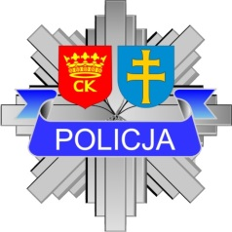
School of Economics, Law and Medical Sciences in Kielce,
Voivodship Police Headquarters in Kielce,
Municipal Police Headquarters in Kielce
and
National Museum in Kielce
cordially invite

……………………………………………………………
to the international scientific conference:

„European police structures in the last 100 years”
which will take place on 24-25 April 2019
starting on 24 April at 2.00 pm in the National Museum in Kielce
continuing on 25 April at 10:00 am in the Main Auditorium of the School of Economics, Law and Medical Sciences in Kielce,
ul. Jagiellońska 109A
We kindly ask you to prepare a paper on the evolution of police structures in your country over the last century. Due to organizational reasons, the time of the lecture is limited to 15-20 minutes.

